38.74: a) and so the overall wavelength shift is 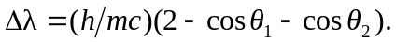
(b) For a single scattering through angle 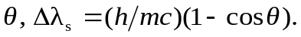
For two successive scatterings through an angle of 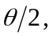 for each scattering,
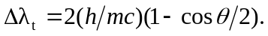
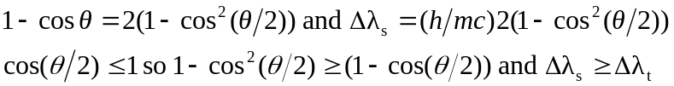
Equality holds only when 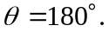
c)
which is indeed greater than the shift found in part (c).

